VARUN BHARGAVA – 241010282
DATA STRUCTURES TASK-10

Task 01: Build a Contact Directory using Binary Search Tree:
(https://github.com/varunnnb/dsa-sem3-iiitnr/blob/main/lab9/lab9-1.c)
You are developing a simple contact directory for a mobile application.
Each contact is stored as a name (string) and a phone number (integer).
To enable fast searching by name, implement the directory using a Binary Search
Tree (BST), where the key is the contact name.
You need to:
1. Create a BST of contacts using the given names and numbers.
2. Print the contacts in alphabetical order (using inorder traversal).

Input:
Contacts = [
("John", 9876543210),
("Alice", 9012345678),
("Bob", 9123456780),
("Eve", 9988776655),
("Charlie", 9090909090)
]

Output:
Alice → 9012345678
Bob → 9123456780
Charlie → 9090909090
Eve → 9988776655
John → 9876543210
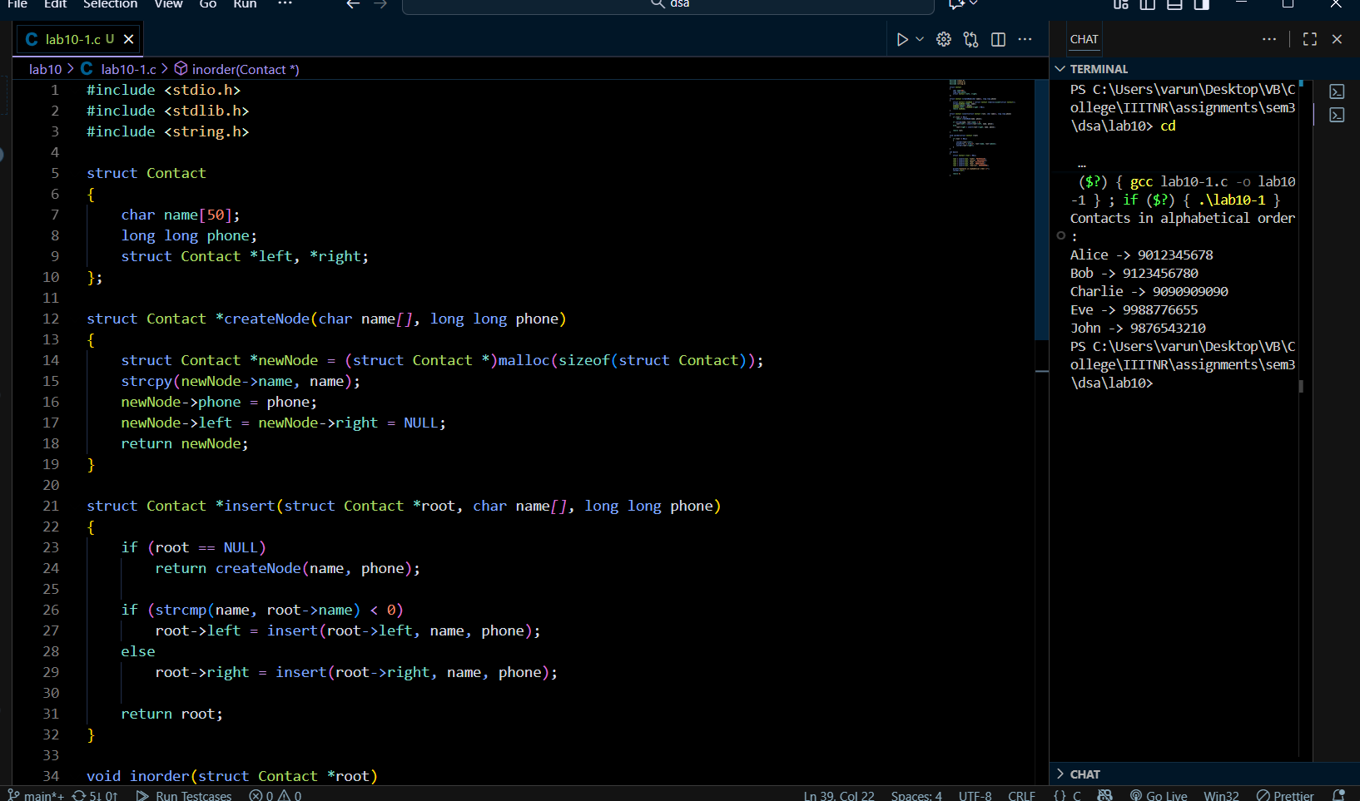
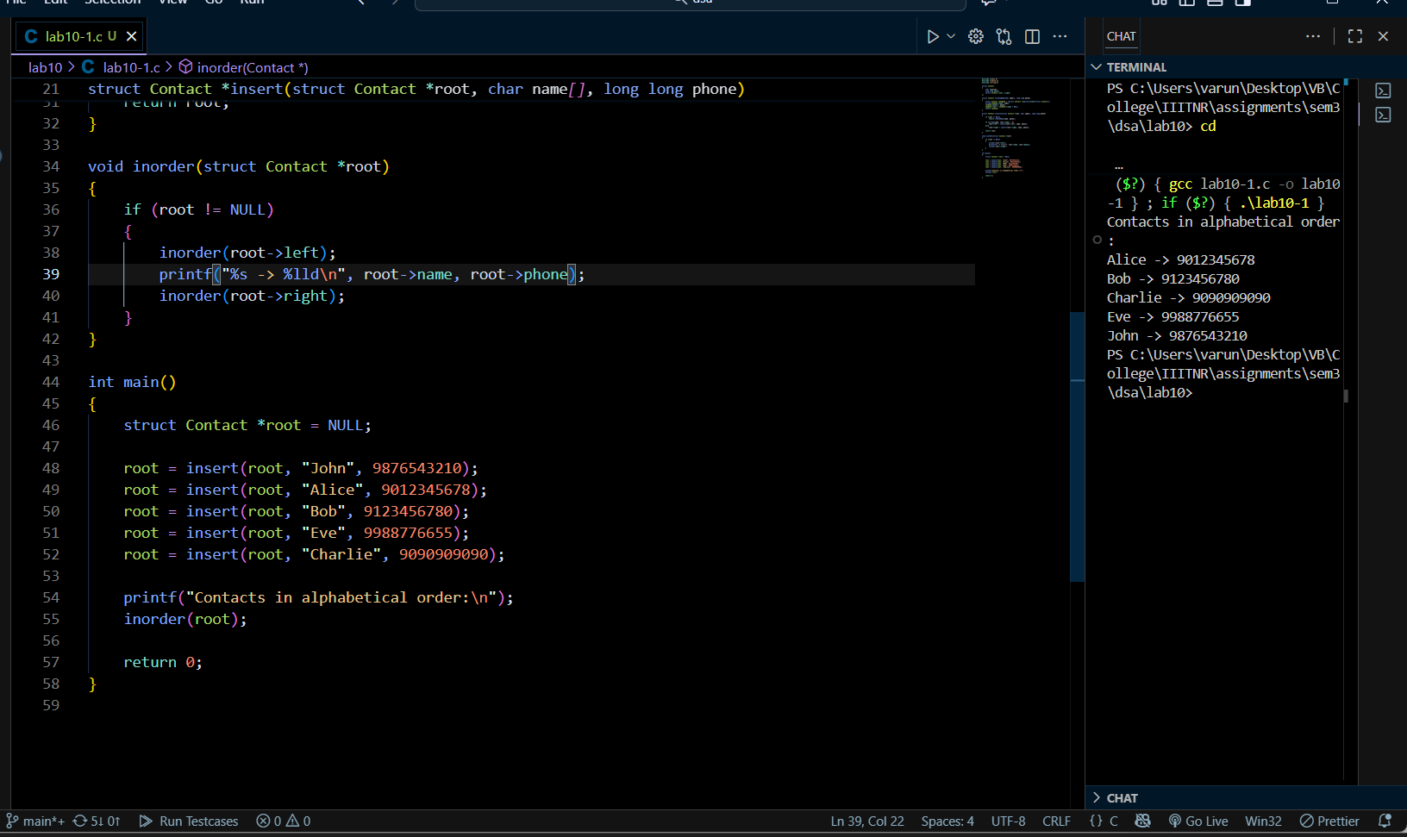

Task 02: Managing Student Records:
( https://github.com/varunnnb/dsa-sem3-iiitnr/blob/main/lab9/lab9-2.c)
You are building a student record management system for a university.
Each student record consists of a student ID (integer) and a CGPA (float).
The system must allow:
1. Adding a new student record
2. Deleting a student record by ID
3. Displaying all students in ascending order of their IDs
The data structure should be a Binary Search Tree, where:
● Key → Student ID
● Value → CGPA
Input:
Insert (50, 8.2) → {Insert(Student ID,CGPA)}
Insert (30, 7.5)
Insert (70, 9.1)
Insert (20, 6.8)
Insert (40, 7.9)
Insert (60, 8.4)
Insert (80, 9.3)

Delete 20
Delete 70

Output:
30 → 7.5
40 → 7.9
50 → 8.2
60 → 8.4
80 → 9.3

